The Family Educational Rights and Privacy Act (FERPA) is a federal law that secures the privacy of educational records. This includes student grades, class schedule and financial aid information. However, students have the option to share access to their educational records with friends and family and you have the option to view those with access.
Use this guide to view individuals with third party access to student records.

INSTRUCTIONS
- Log into Workday. To locate the student’s record, enter “Student: [Student Name or ID]” in the search bar. Press Enter.



- In the student record, click “Contact” and click the “Friends and Family” tab.

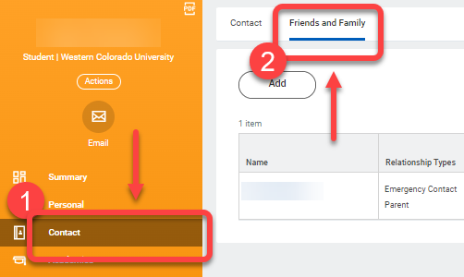

- The screen will display a table with the student’s contacts. Scroll to the right and locate the Third Party column. Individuals with third party user access will display “Yes” in this column.

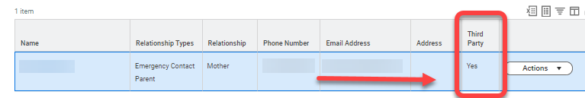

- To view the specific permissions granted to this user, click the contact’s name in the Name column.
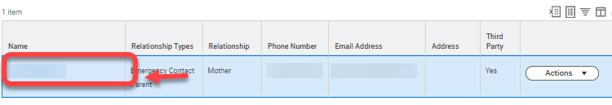

- The View Friends and Family Details page will appear. Locate and click the Permissions tab.

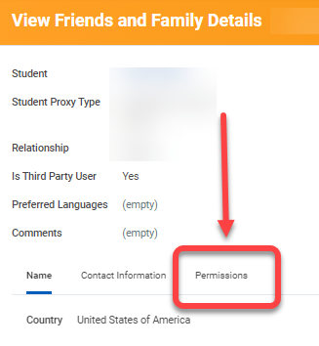

- The Current Permissions table will appear for this contact. The tasks authorized by the student for this contact will be listed in the Allowed Tasks column. The student can change permissions at any time.

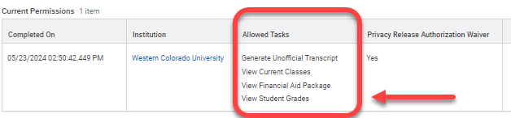

- There are four tasks available for third party users. See table below for details.

Permission | Description
View Financial Aid Package | Allows the third party user to see the student’s financial aid details, including estimated costs for the year.
View Current Classes | Allows the third party user to see the classes the student is currently registered for.
View Student Grades | Allows the third party user to see the student’s grades.
Generate Unofficial Transcript | Allows the third party user to see the student’s unofficial transcript.

